Redis & Caching in Spring Boot Application

Why Do We Need Caching?
In real-world applications (especially E-commerce, Banking, OTT, Enterprise systems):
- Thousands or millions of users make repeated requests
- Many requests ask for same data
- Every request going to the database:
  - Increases latency
  - Overloads application server
  - Overloads database
  - Degrades overall performance
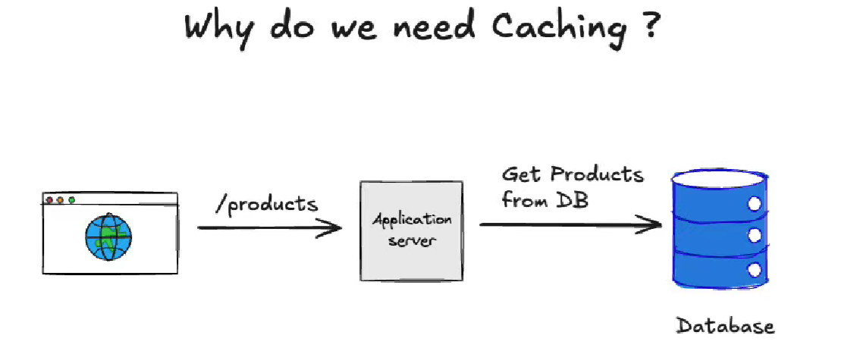
Problem Without Caching
- Database becomes the bottleneck
- Slow response times
- Poor user experience
- Higher infrastructure cost
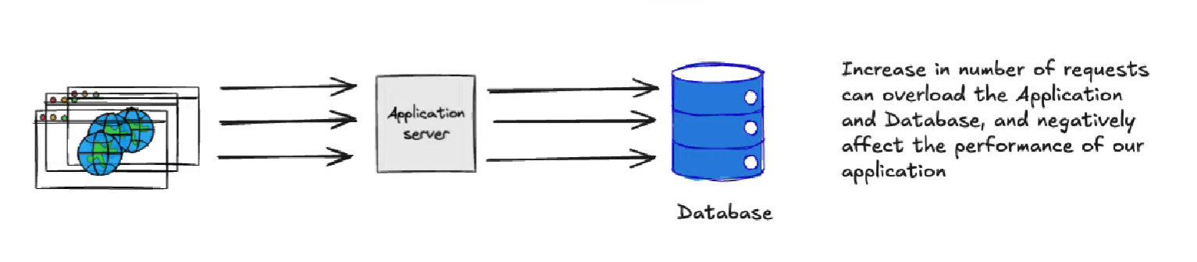
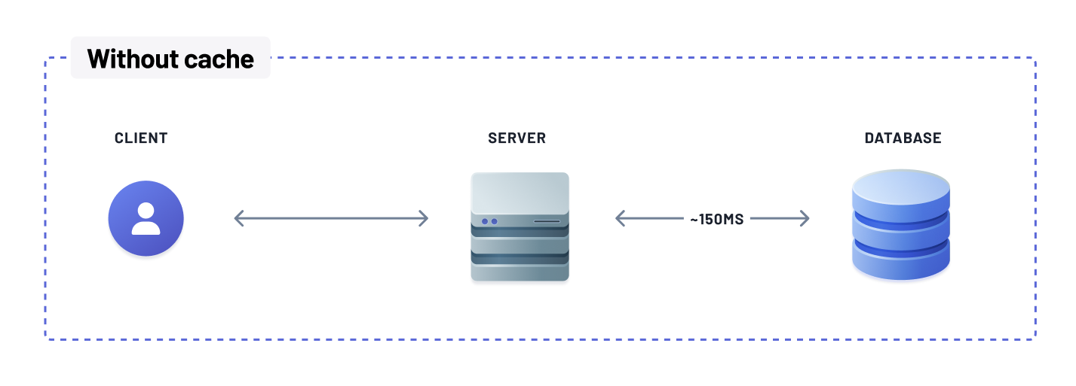
What Happens?
- Thousands of concurrent DB calls
- Increased query execution time
- DB connection pool exhaustion
- Application slowdown or failure

Introducing Cache to Solve This Problem
Instead of hitting the database every time, we introduce a Cache layer.
New Flow:
- Client → Application Server
- Application Server → Cache (Redis)
- If data exists → return immediately
- If not → fetch from DB, save to cache
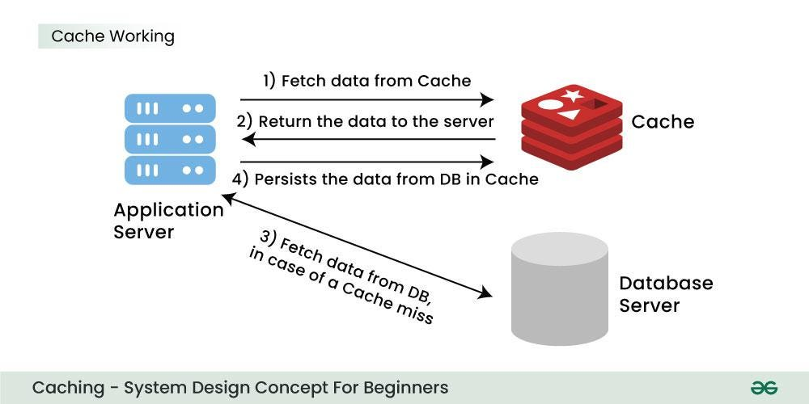
What Exactly Is Caching?
Caching is the process of:
Storing frequently accessed data in a fast-access storage layer so future requests can be served quickly without hitting the database again.
Key Idea:
- First request → Database
- Store result → Cache
- Next requests → Cache (instead of DB)
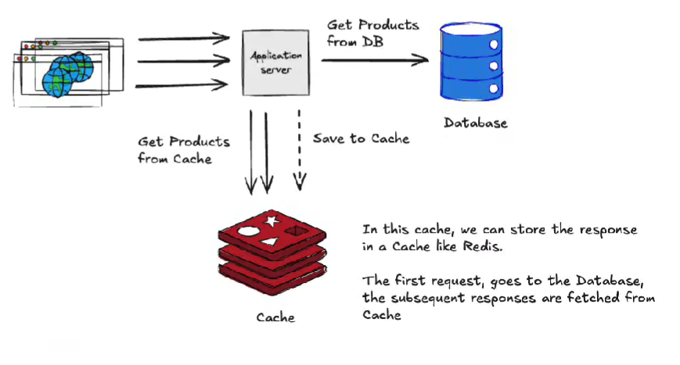


Client → Server → Database (Without Cache)
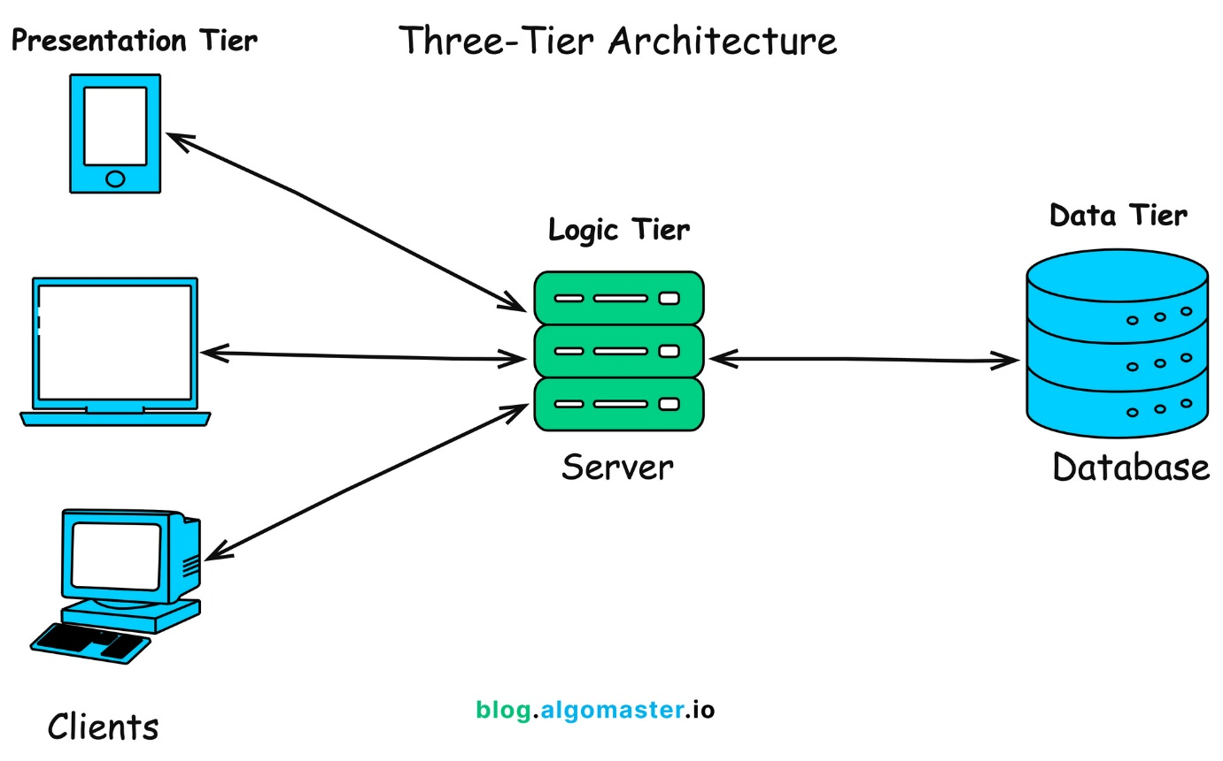

Flow:
- Client sends request
- Request goes to Application Server
- Application Server queries Database
- Database returns response
- Response goes back to Client
👉 Every request hits the database
Performance Issue: High Number of Requests (Without Cache)

Client → Server → Cache → Database (With Redis)

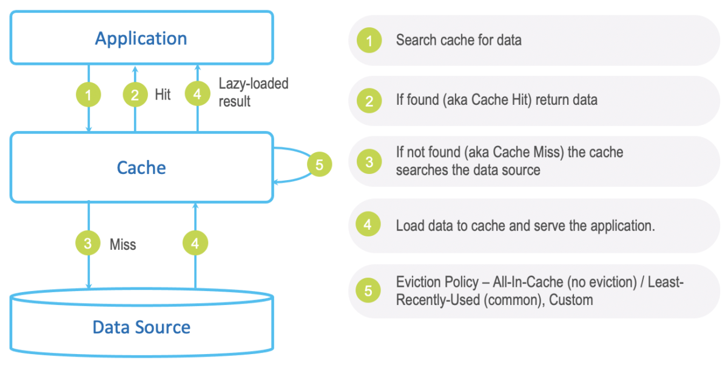

Efficient Request Flow:
- Client sends request
- Application checks Redis cache
- If data exists → return response
- If not:
  - Fetch from DB
  - Store in Redis
  - Return response
👉 Database is hit only once

How Cache Lookup Works in Request–Response Cycle
Step-by-Step:
- Client requests product list
- Application checks Redis using a key
- Cache Hit:
  - Response returned in milliseconds
- Cache Miss:
  - DB queried
  - Result stored in Redis
  - Response returned
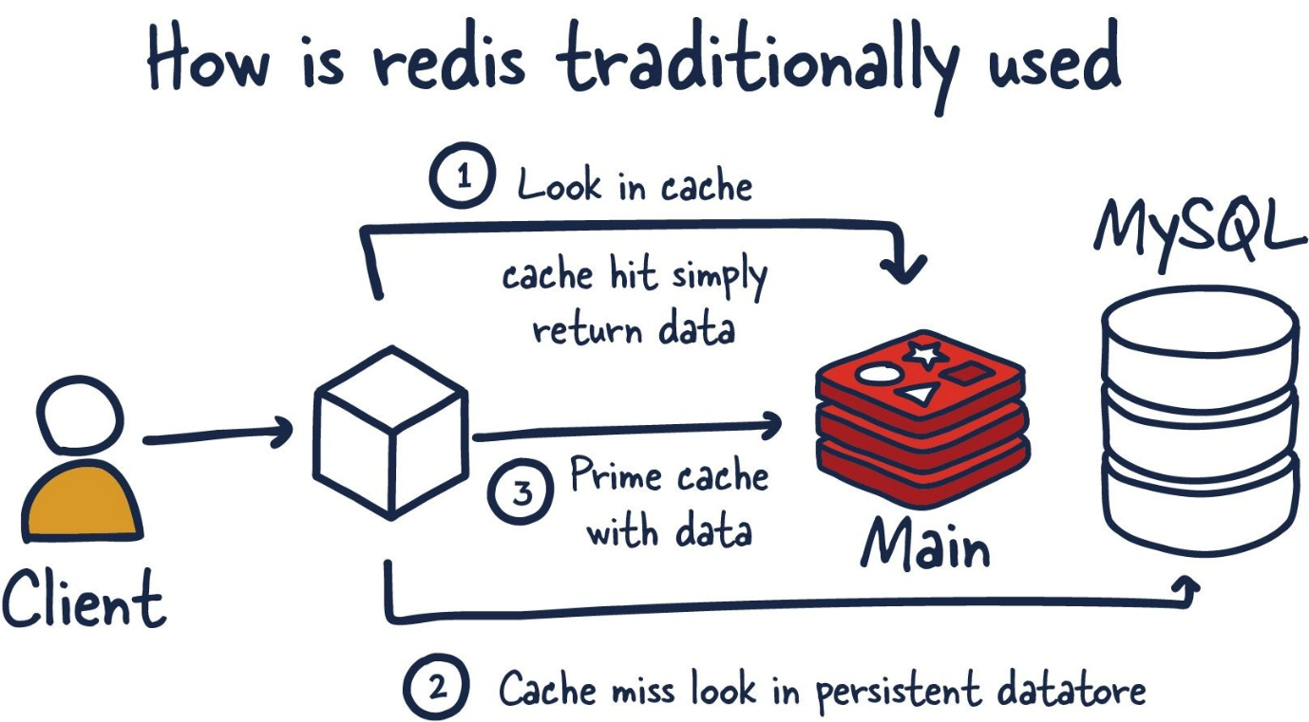

What Is Redis?
Redis (Remote Dictionary Server) is:
- An in-memory data store
- Extremely fast
- Used as:
  - Cache
  - Database
  - Message broker
Key Characteristics:
- In-memory (RAM based)
- Key–Value store
- Very low latency (microseconds)
- Supports persistence (optional disk storage)
Redis is designed for speed and simplicity.

What Redis Does:
- Stores data in key–value format
- Keeps frequently accessed data in memory
- Reduces database load
- Improves application performance

Redis as a NoSQL Database
Redis is a NoSQL database, but different from:
- MongoDB , PostgreSQL , MySQL
Key Difference:
- Traditional DB → Disk based
- Redis → Memory based (RAM)

Redis as Giant JSON (Key–Value Store)
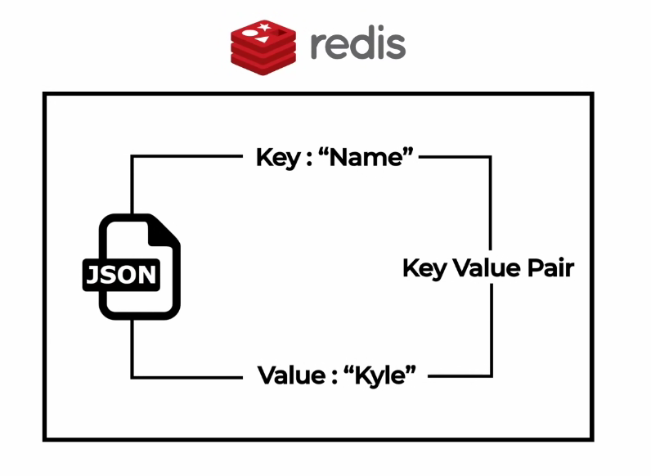
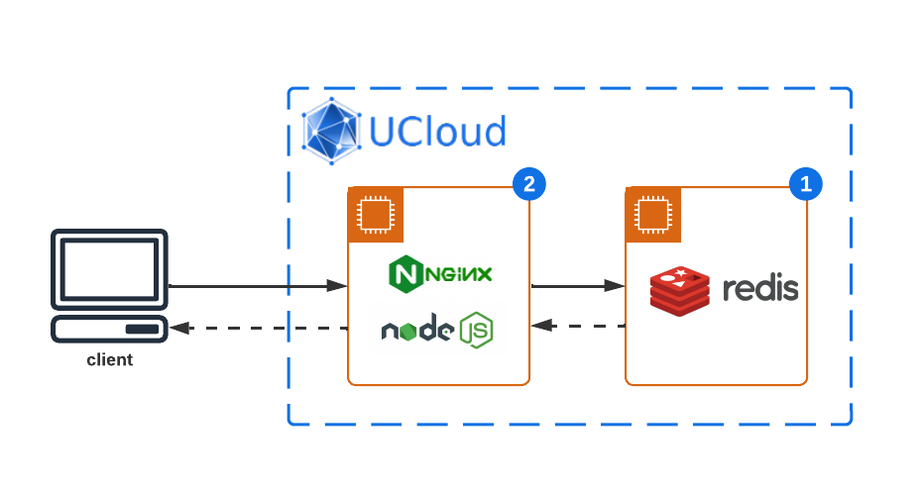
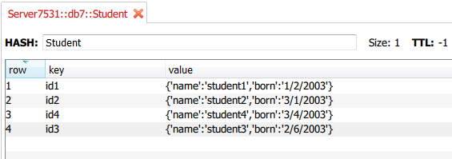
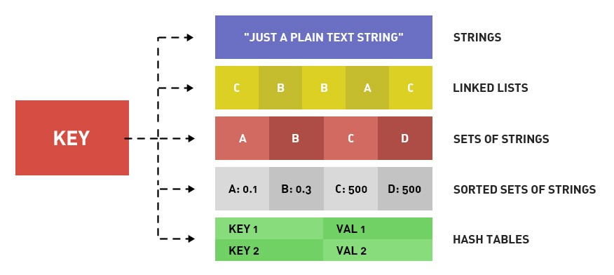
Think of Redis as:
{
"product:101": {
"name": "iPhone",
"price": 75000
},
"product:102": {
"name": "Samsung",
"price": 65000
}
}
- Keys → Unique identifiers
- Values → Objects / Strings / Lists / Sets
Cache, Redis Cache & Cache Worker Explained
🔹 Cache
- Temporary storage
- Holds frequently used data
- Faster than database
🔹 Redis Cache
- Cache implemented using Redis
- Stores data in memory
- Shared across application instances
🔹 Cache Worker
Cache Worker Responsibilities:
- Monitors database changes
- Updates Redis when DB data changes
- Ensures cache consistency
- Prevents stale data
👉 When DB data changes → Cache Worker updates Redis → Next request gets fresh data
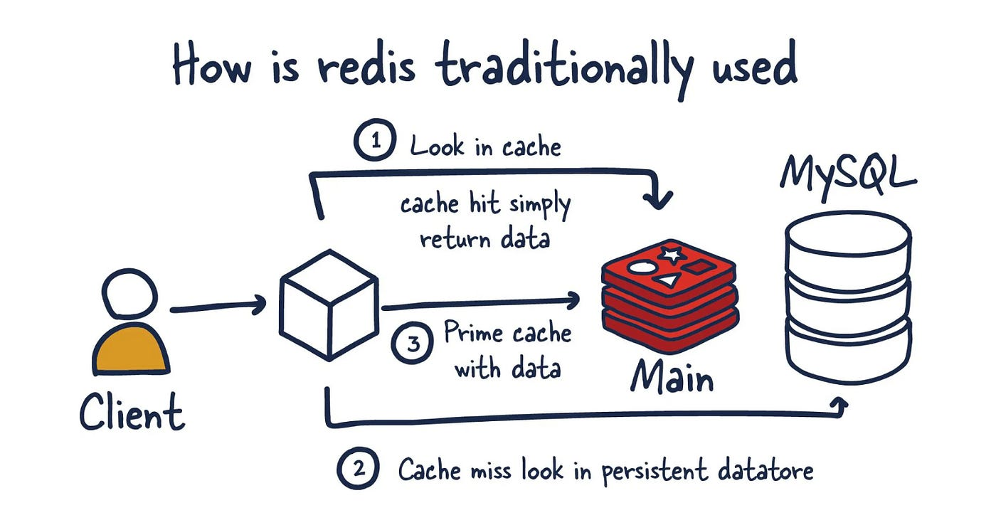

Example: E-Commerce Product API
Without Cache:
- /products
- Hits database every time
- Slow for high traffic
With Redis:
- First request:
  - Fetch from DB
  - Save in Redis
- Subsequent requests:
  - Served from Redis
  - Ultra-fast response

Why Do We Need Redis?
- Reduce database load
- Improve response time
- Handle high traffic
- Scale applications efficiently
- Improve system reliability
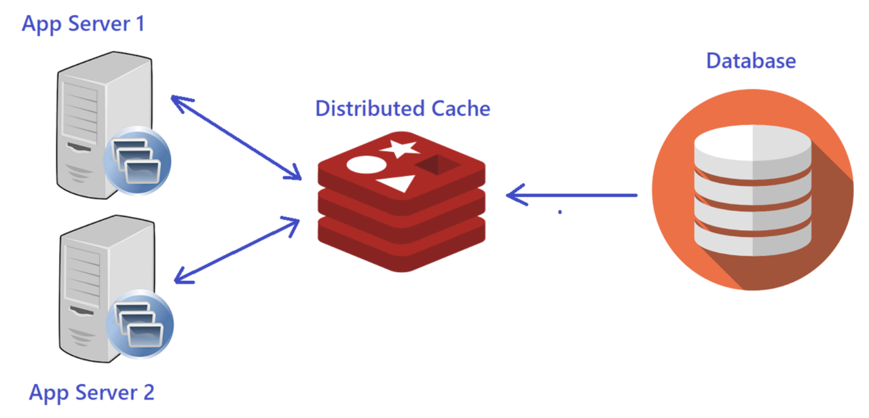
When Should We Use Redis?
Ideal Use Cases:
- Frequently read data
- Rarely updated data
- Heavy read operations
- API response caching
- Session management
- Product catalog
- User profile data
❌ Avoid Redis when:
- Data changes too frequently
- Strong transactional consistency is required

Redis Architecture Explained
(Server A / Server B → Master Redis → Slave Redis → Disk Persistence)
What are Server A and Server B?
Server A & Server B (Application Servers)
- These are Spring Boot application servers
- Multiple servers are used to:
  - Handle high traffic
  - Support load balancing
  - Avoid single point of failure
Example:
Imagine an E-commerce application:
- Server A handles requests from User 1, User 2
- Server B handles requests from User 3, User 4
- Both servers need same product data
Instead of each server hitting the database → they use Redis
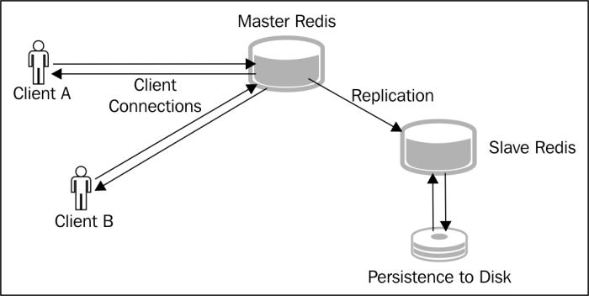

High-Level Architecture Overview
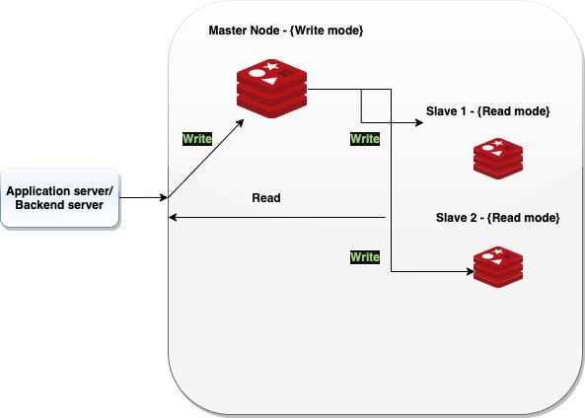

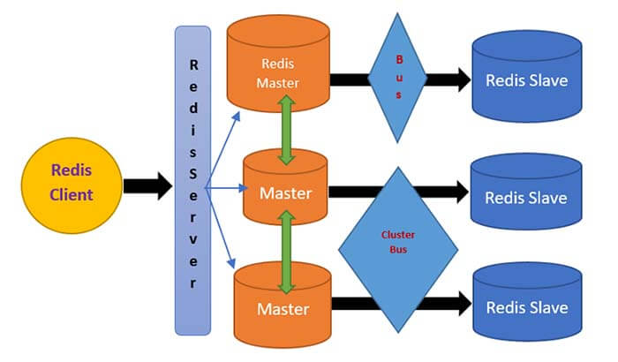

This architecture is commonly used in production systems to achieve:
- High performance
- Scalability
- High availability
- Data safety
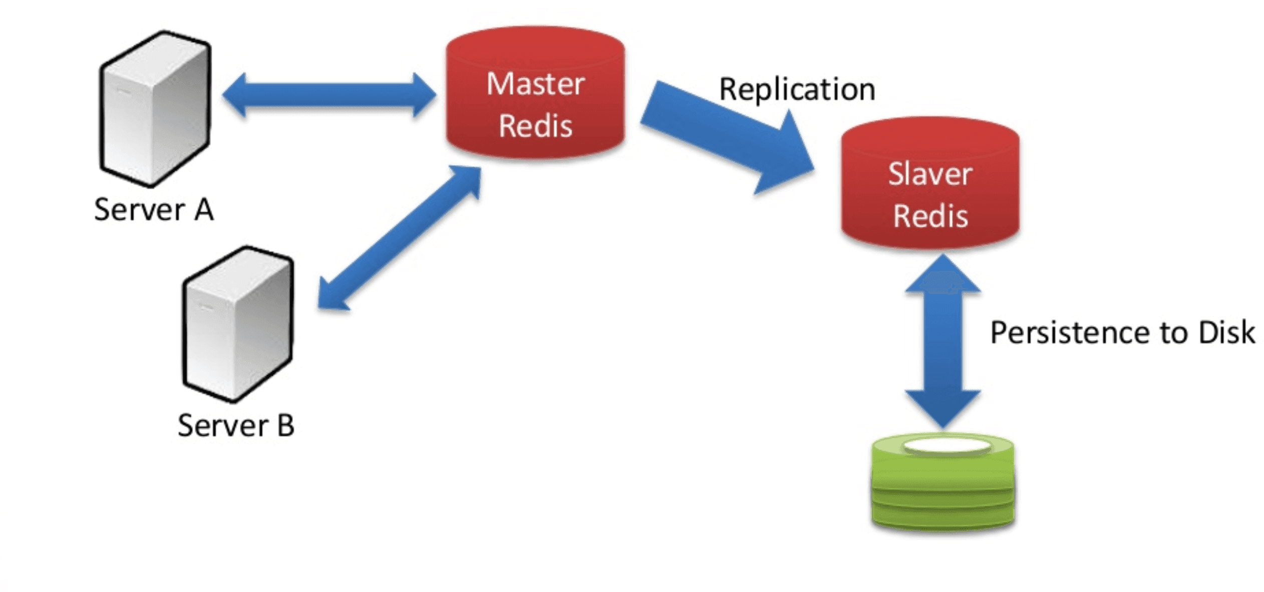
Master Redis (Primary Cache Node)

What is Master Redis?
- Main Redis instance
- Handles:
  - WRITE operations
  - UPDATE operations
- Acts as the single source of truth for cache
Example:
When Server A requests product data:
- Cache miss
- Server A fetches data from DB
- Stores data in Master Redis
- Master Redis holds latest cached data

How Requests Flow (Simple Example)
Scenario: Fetch Product List
First Request (Cache Miss)
Client → Server A → Master Redis (miss)
↓
Database
↓
Save to Master Redis
↓
Response
Subsequent Requests (Cache Hit)
Client → Server B → Master Redis → Response
✅ Database is not touched again

Redis Replication (Master → Slave Redis)

What Is Redis Replication?
- Master Redis copies data to one or more Slave Redis nodes
- Happens automatically
- Slaves are read-only

Why Replication Is Needed?
- High Availability
  - If Master fails → Slave can take over
- Read Scalability
  - Multiple read requests can go to Slaves
- Data Backup in Memory

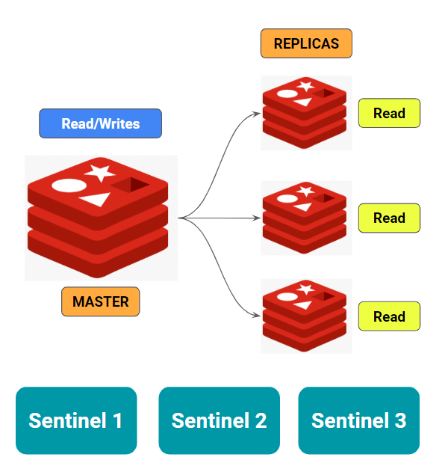

Slave Redis (Replica Node)
What Does Slave Redis Do?
- Receives data from Master Redis
- Keeps exact copy of cache
- Handles read operations
- Cannot write data
Example:
- Server A writes product data → Master Redis
- Slave Redis immediately gets the same data
- Server B can read from Slave Redis

Why Multiple Application Servers Use Same Redis?
Without Redis:
- Server A cache ≠ Server B cache
- Inconsistent data
- More DB calls
With Redis:
- Shared cache
- Consistent data
- Faster responses
- Lower DB load
Persistence to Disk (Redis Durability)
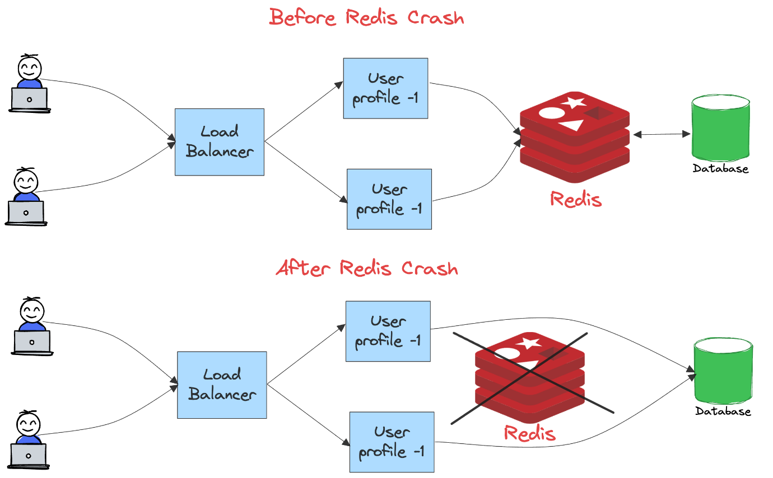
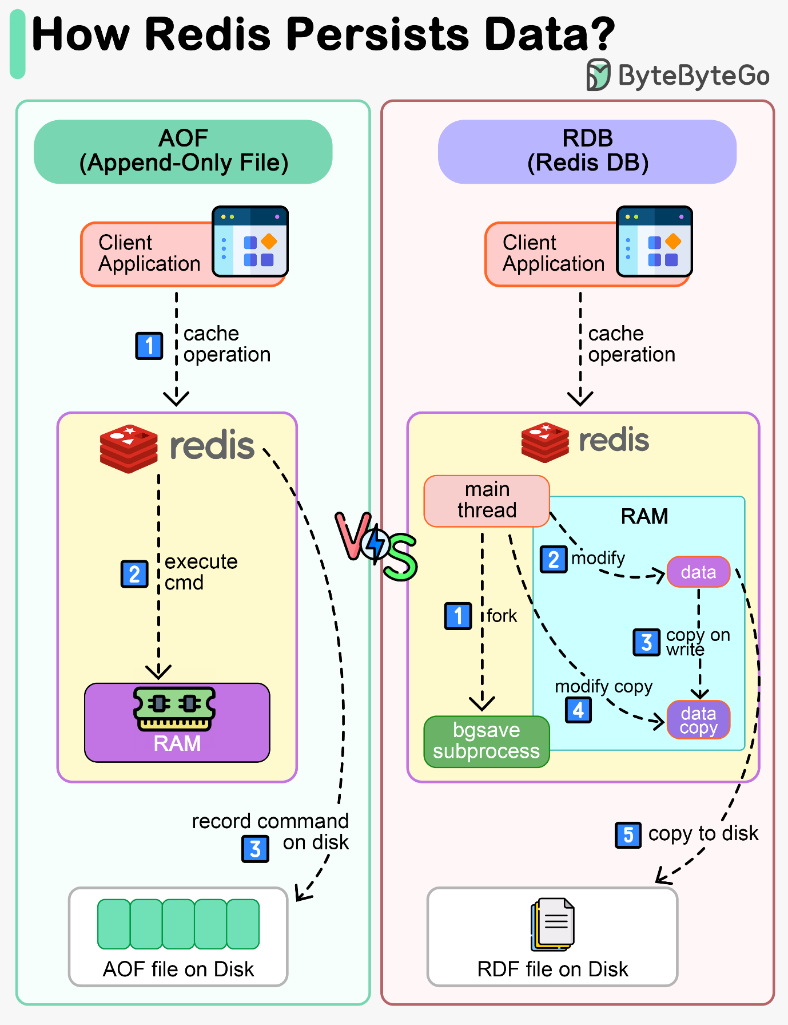
Redis Is In-Memory… Then Why Disk?
Yes, Redis stores data in RAM, but it also supports persistence.
Persistence Means:
Redis periodically saves in-memory data to disk
Types of Redis Persistence
🔹 RDB (Snapshot Based)
- Takes snapshot of data
- Saves to disk at intervals
- Faster restart
🔹 AOF (Append Only File)
- Logs every write operation
- More durable
- Slightly slower
👉 In production, RDB + AOF together are used

Why Persistence Is Important?
Example:
- Redis server crashes
- RAM data is lost
- Redis restarts
- Data is restored from disk
Without persistence:
❌ Cache completely lost
With persistence:
✅ Cache restored automatically

Complete Flow (End-to-End Example)
Example: Product API /products
- User sends request
- Server A checks Redis
- Cache miss → DB queried
- Data stored in Master Redis
- Data replicated to Slave Redis
- Data persisted to disk
- Response returned
- Next request served from Redis

Why This Architecture Is Powerful
Feature | Benefit
Multiple Servers | High traffic handling
Master Redis | Fast writes
Slave Redis | Read scalability
Replication | High availability
Persistence | Data safety

